Alur Aplikasi - Sistem Tracking Status Dokumen Notaris
1. Overview Alur Aplikasi
Dokumen ini menjelaskan alur aplikasi secara naratif untuk tiga use case utama:
- Klien cek status dokumen
- Sistem ambil data dan validasi
- Notaris/staff update status
2. Alur 1: Klien Cek Status Dokumen
2.1 Narasi Lengkap
Aktor: Klien (pengguna layanan notaris)
Tujuan: Klien ingin mengetahui status progress dokumen mereka secara mandiri tanpa harus menghubungi kantor notaris.
Precondition: Klien memiliki nomor registrasi yang diberikan saat pendaftaran dokumen.
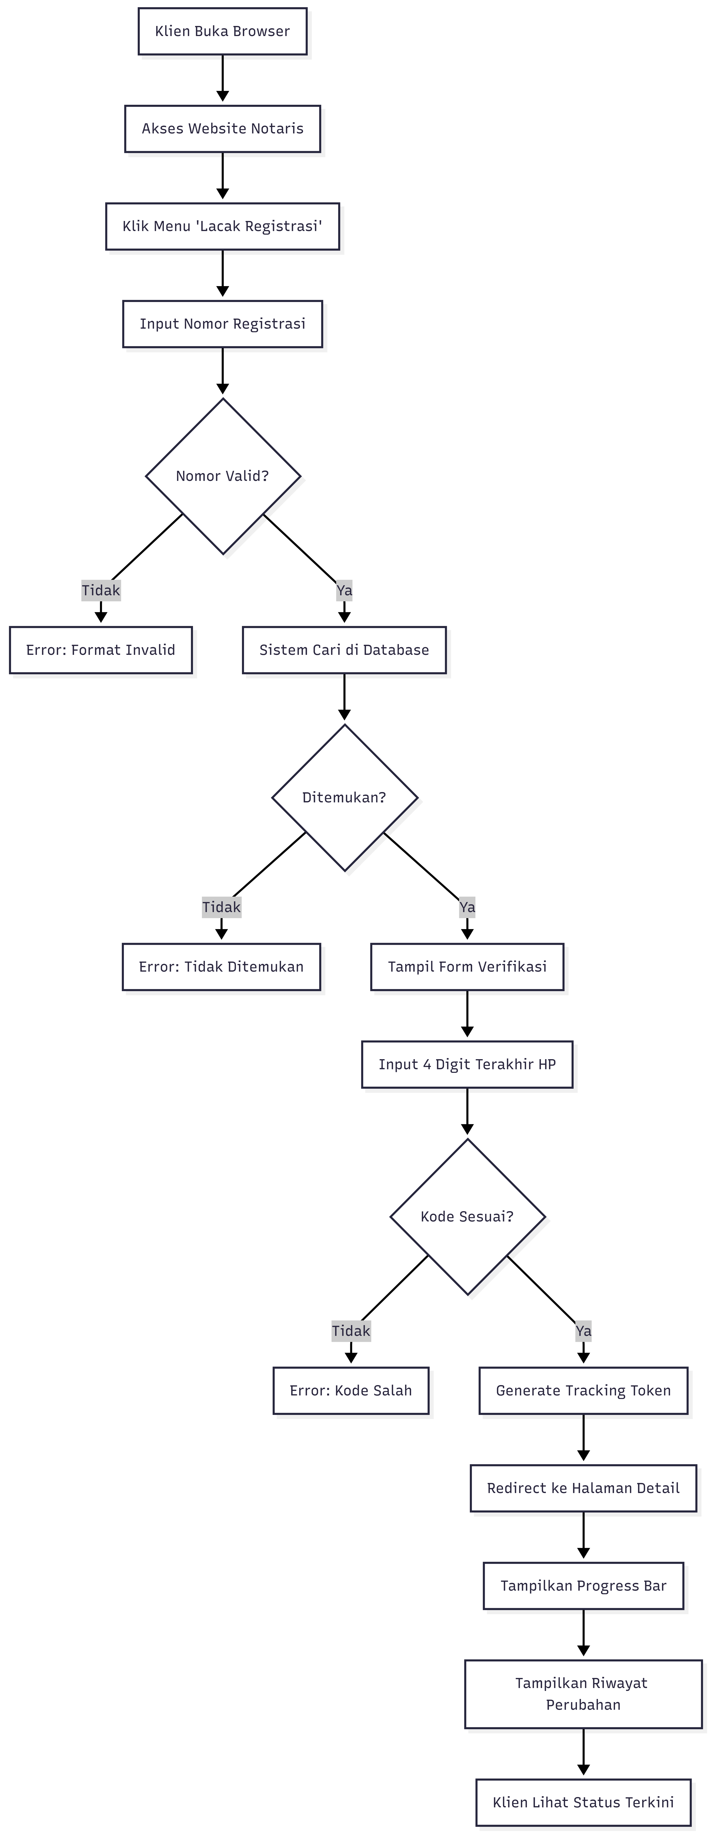
2.2 Step-by-Step Detail
Step 1: Akses Halaman Tracking
- User Action: Klien membuka browser dan mengakses website Kantor Notaris Sri Anah
- System Response: Homepage ditampilkan dengan menu navigasi
- Navigation: Klien klik menu "Lacak Registrasi" di navigation bar
- URL: /index.php?gate=lacak
Step 2: Input Nomor Registrasi
- User Action: Klien mengetik nomor registrasi pada form search
- Example Input: NP-20260326-1234
- System Action: Validasi format (harus NP-YYYYMMDD-XXXX)
Step 3: Validasi Nomor Registrasi
System Process:
- Sanitasi input (hapus karakter berbahaya)
- Query database: SELECT * FROM registrasi WHERE nomor_registrasi = 'NP-20260326-1234'
3. Check hasil query
Kemungkinan Hasil:
- Tidak Valid Format: Error "Format nomor registrasi tidak valid"
- Tidak Ditemukan: Error "Nomor registrasi tidak ditemukan"
- Ditemukan: Lanjut ke verifikasi
Step 4: Verifikasi 4 Digit HP
- System Response: Form verifikasi ditampilkan
- User Action: Klien input 4 digit terakhir nomor HP mereka
- Example: Jika HP klien 0812-3456-7890, input: 7890
Security Measure:
- Rate limiting: Maksimal 5 percobaan per menit
- Logging failed attempts untuk deteksi brute force
Step 5: Validasi Kode Verifikasi
System Process:
  - Ambil data klien dari registrasi
  - Extract 4 digit terakhir dari nomor HP (remove non-numeric first)
  - Bandingkan dengan input klien
  - Jika match → generate token
  - Jika tidak match → error
Contoh:
- HP di Database: 081234567890
- Clean HP: 081234567890
- Last 4: 7890
- Input Klien: 7890
- Result: MATCH ✅
Step 6: Generate Tracking Token
System Process:
- Create payload: {id: registrasi_id, code: verification_code, exp: time + 24h}
- Encode base64
- Generate HMAC-SHA256 signature
- Format: base64Payload.signature
- Simpan token di database (registrasi.tracking_token)
Token Example:
eyJpZCI6MTIzLCJjb2RlIjoiYTFiMmMzZDQiLCJleHAiOjE3MTY5ODc2NTR9.abc123def456...
Step 7: Tampilkan Progress Tracking
- System Response: Redirect ke halaman detail dengan token
- URL: /index.php?gate=detail&token=eyJpZCI6...
Page Content:
  - Nomor registrasi
  - Nama klien (disamarkan sebagian)
  - Layanan
  - Status saat ini
  - Progress bar 15 status
  - Estimasi waktu
  - Riwayat perubahan (timeline)
Step 8: Lihat Riwayat (Process Log)
- System Query: SELECT * FROM registrasi_history WHERE registrasi_id = ? ORDER BY created_at DESC
Display Format:
┌─────────────────────────────────────────────────┐
│ 26 Mar 2026, 14:30 │
│ Status: Pembayaran Admin → Validasi Sertifikat │
│ Catatan: Berkas lengkap, lanjut validasi │
│ Oleh: Admin │
└─────────────────────────────────────────────────┘
3. Alur 2: Sistem Ambil Data dan Validasi
3.1 Narasi Lengkap
Aktor: Sistem (Backend)
Tujuan: Mengambil data registrasi dari database dan melakukan validasi keamanan.
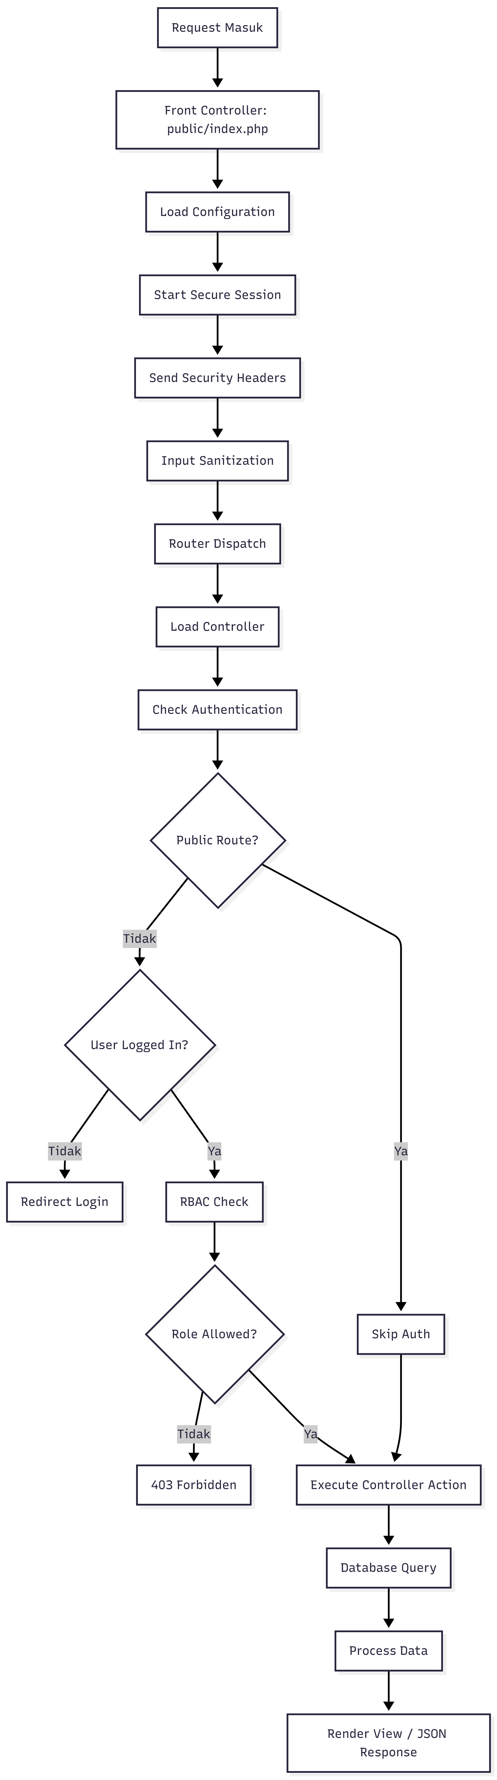
3.2 Request Lifecycle Detail
Phase 1: Front Controller (public/index.php)
// 1. Define BASE_PATH
define('BASE_PATH', dirname(__DIR__));

// 2. Register Autoloader
App\Core\Autoloader::register();
App\Core\Autoloader::addNamespace('App\\', BASE_PATH . '/app/');
App\Core\Autoloader::addNamespace('Modules\\', BASE_PATH . '/modules/');

// 3. Load Configuration
require_once BASE_PATH . '/config/app.php';

// 4. Load Utils
require_once BASE_PATH . '/app/Core/Utils/helpers.php';
require_once BASE_PATH . '/app/Core/Utils/security.php';

// 5. Secure Session
App\Security\Auth::startSecureSession();

// 6. Security Headers
sendSecurityHeaders();
header('Cache-Control: no-cache, no-store, must-revalidate');

// 7. Input Sanitization
App\Security\InputSanitizer::sanitizeGlobal();

// 8. Load Routes
require_once BASE_PATH . '/config/routes.php';

// 9. Dispatch Router
App\Core\Router::dispatch();

Phase 2: Router Dispatch
// Router::dispatch()
$gate = $_GET['gate'] ?? 'home';
$method = $_SERVER['REQUEST_METHOD'];

// Lookup route
$route = self::$routes[$gate][$method] ?? null;

if ($route) {
// Check auth requirement
if ($route['auth'] && !Auth::check()) {
redirect('/index.php?gate=login');
exit;
}

// Check RBAC
if (isset($route['role'])) {
RBAC::enforce($route['role']);
}

// Execute controller
[$controllerClass, $action] = $route['handler'];
$controller = new $controllerClass();
$controller->$action();
}
Phase 3: Database Query
// Example: Tracking search
public function findByNomorRegistrasi($nomor) {
return Database::selectOne(
"SELECT p.id, p.klien_id, p.nomor_registrasi, p.status,
k.nama AS klien_nama, k.hp AS klien_hp,
l.nama_layanan
FROM registrasi p
LEFT JOIN klien k ON p.klien_id = k.id
LEFT JOIN layanan l ON p.layanan_id = l.id
WHERE p.nomor_registrasi = :nomor
LIMIT 1",
['nomor' => $nomor]
);
}
Phase 4: Token Validation
// verifyTrackingToken()
function verifyTrackingToken($token) {
// 1. Parse token
$parts = explode('.', $token);
if (count($parts) !== 2) return false;

// 2. Decode payload
$payload = base64_decode($parts[0]);
$data = json_decode($payload, true);
if (!$data) return false;

// 3. Verify signature
$expectedSig = hash_hmac('sha256', $parts[0], SECRET_KEY);
if (!hash_equals($expectedSig, $parts[1])) return false;

// 4. Check expiration
if (isset($data['exp']) && $data['exp'] < time()) return false;

return $data;
}

4. Alur 3: Notaris/Staff Update Status
4.1 Narasi Lengkap
Aktor: Staff Admin / Notaris
Tujuan: Update status progress dokumen dengan validasi workflow.
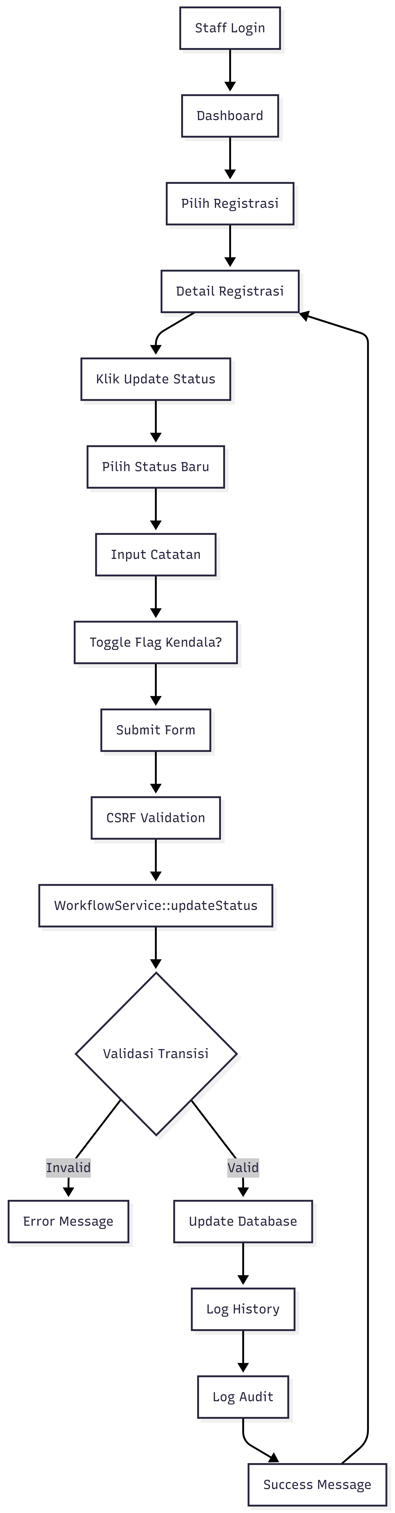
4.2 Step-by-Step Detail
Step 1: Authentication
User Action: Staff login dengan username dan password
System Process:
- Query user by username
- password_verify() dengan bcrypt hash
- Start secure session dengan fingerprinting
- Log audit: 'login'
- Redirect ke dashboard
Session Security:
// Session fingerprinting
$fingerprint = hash('sha256', $_SERVER['HTTP_USER_AGENT'] . $_SERVER['REMOTE_ADDR']);
$_SESSION['user_fingerprint'] = $fingerprint;

// Validate on each request
if ($_SESSION['user_fingerprint'] !== $currentFingerprint) {
session_destroy(); // Hijacking detected!
}
Step 2: Akses Detail Registrasi
- Navigation: Dashboard → Registrasi → Klik nomor registrasi
- URL: /index.php?gate=registrasi_detail&id=123
- Controller: Dashboard\Controller::showRegistrasi()
Database Query:
SELECT registrasi.*, klien.*, layanan.*
FROM registrasi
LEFT JOIN klien ON registrasi.klien_id = klien.id
LEFT JOIN layanan ON registrasi.layanan_id = layanan.id
WHERE registrasi.id = 123
Step 3: Update Status Form
<!-- Simplified form structure -->
<form method="POST" action="/index.php?gate=update_status">
<input type="hidden" name="csrf_token" value="abc123...">
<input type="hidden" name="registrasi_id" value="123">

<select name="status">
<option value="draft">Draft</option>
<option value="pembayaran_admin">Pembayaran Admin</option>
<!-- ... other statuses ... -->
</select>

<textarea name="catatan"></textarea>

<label>
<input type="checkbox" name="flag_kendala">
Flag Kendala
</label>

<button type="submit">Update Status</button>
</form>
Step 4: Workflow Validation
// WorkflowService::updateStatus()

// 1. Load registrasi
$registrasi = $this->registrasiModel->findById($registrasiId);

// 2. Check final status
if (in_array($registrasi['status'], ['selesai', 'ditutup', 'batal'])) {
return ['success' => false, 'message' => 'Status final tidak bisa diubah'];
}

// 3. Check locked
if ($registrasi['is_locked']) {
return ['success' => false, 'message' => 'Registrasi sedang dikunci'];
}

// 4. Get status order
$currentOrder = STATUS_ORDER[$registrasi['status']];
$newOrder = STATUS_ORDER[$newStatus];

// 5. Check backward transition
if ($newOrder < $currentOrder && $newStatus !== 'batal') {
if ($registrasi['status'] !== 'perbaikan') {
return ['success' => false, 'message' => 'Status tidak bisa mundur'];
}
}

// 6. Check cancellation
if ($newStatus === 'batal') {
if (!in_array($registrasi['status'], CANCELLABLE_STATUSES)) {
return ['success' => false, 'message' => 'Tidak bisa batal setelah pajak'];
}
}

// 7. Update database
$this->registrasiModel->updateStatus($registrasiId, $newStatus, $keterangan, $catatan);

// 8. Handle flag kendala
if ($flagKendala !== null) {
// Toggle kendala logic
}

// 9. Save history
$this->registrasiHistoryModel->create([
'registrasi_id' => $registrasiId,
'status_old' => $registrasi['status'],
'status_new' => $newStatus,
'catatan' => $catatan,
'user_id' => $userId,
'user_name' => $userName,
'user_role' => $role,
'ip_address' => $_SERVER['REMOTE_ADDR'],
]);

// 10. Audit log
AuditLog::create([
'user_id' => $userId,
'role' => $role,
'action' => 'update',
'old_value' => json_encode(['status' => $registrasi['status']]),
'new_value' => json_encode(['status' => $newStatus]),
]);
Step 5: Status Transition Examples
Valid Transitions:
✅ draft → pembayaran_admin (forward)
✅ pembayaran_admin → validasi_sertifikat (forward)
✅ draft → batal (cancellable)
✅ perbaikan → pembayaran_pajak (loop back allowed)
Invalid Transitions:
❌ validasi_sertifikat → draft (backward not allowed)
❌ pembayaran_pajak → batal (past cancellation limit)
❌ selesai → pendaftaran (final status read-only)

5. Alur 4: Notaris Finalisasi Kasus
5.1 Narasi Lengkap
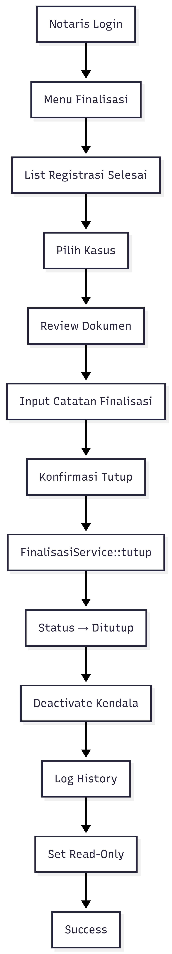
5.2 Detail Process
// FinalisasiService::tutupRegistrasi()

public function tutupRegistrasi($registrasiId, $userId, $role, $notes = null) {
// 1. Load registrasi
$registrasi = $this->registrasiModel->findById($registrasiId);

// 2. Check status must be 'selesai'
if ($registrasi['status'] !== 'selesai') {
return ['success' => false, 'message' => 'Status harus selesai untuk finalisasi'];
}

// 3. Update status to 'ditutup'
$this->registrasiModel->update($registrasiId, [
'status' => 'ditutup',
'is_finalized' => 1,
'finalized_at' => date('Y-m-d H:i:s'),
'finalized_by' => $userId,
'finalization_notes' => $notes,
]);

// 4. Deactivate all kendala flags
$this->kendalaModel->deactivateAll($registrasiId);

// 5. Save history
$this->registrasiHistoryModel->create([
'registrasi_id' => $registrasiId,
'status_old' => 'selesai',
'status_new' => 'ditutup',
'catatan' => $notes,
'user_id' => $userId,
'user_name' => $userName,
'user_role' => $role,
]);

// 6. Audit log
AuditLog::create([
'user_id' => $userId,
'role' => $role,
'action' => 'finalize',
'old_value' => json_encode(['status' => 'selesai']),
'new_value' => json_encode(['status' => 'ditutup']),
]);

return ['success' => true, 'message' => 'Kasus berhasil ditutup'];
}
6. Alur 5: CMS Management
6.1 Narasi
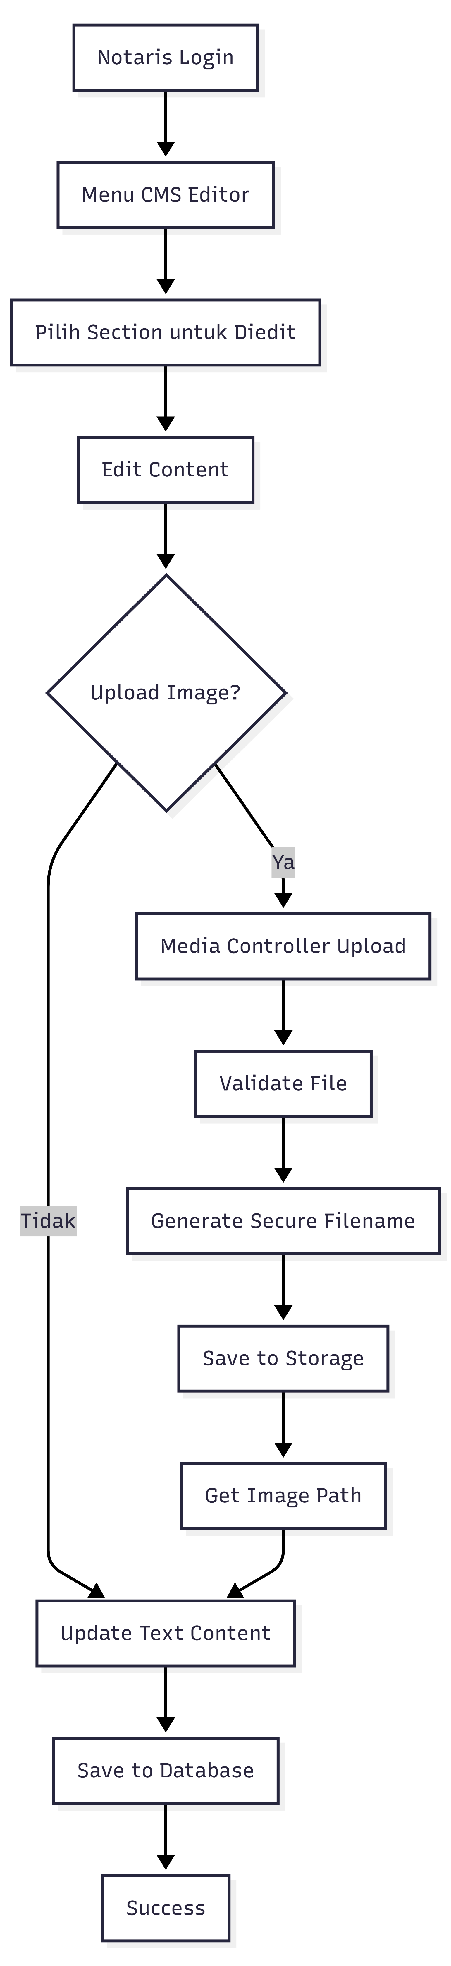
6.2 Upload Flow
// Media\Controller::upload()

public function upload() {
// 1. Check auth
RBAC::enforce('notaris');

// 2. Validate file
if (!isset($_FILES['image'])) {
return json(['success' => false, 'message' => 'No file']);
}

$file = $_FILES['image'];

// 3. Check size (max 5MB)
if ($file['size'] > MAX_UPLOAD_SIZE) {
return json(['success' => false, 'message' => 'File too large']);
}

// 4. Check extension
$ext = strtolower(pathinfo($file['name'], PATHINFO_EXTENSION));
if (!in_array($ext, ['jpg', 'jpeg', 'png', 'pdf'])) {
return json(['success' => false, 'message' => 'Invalid file type']);
}

// 5. Generate secure filename
$secureName = 'img_' . bin2hex(random_bytes(16)) . '.' . $ext;

// 6. Move file
$destination = PUBLIC_PATH . '/assets/images/' . $secureName;
move_uploaded_file($file['tmp_name'], $destination);

// 7. Return path
return json([
'success' => true,
'path' => '/assets/images/' . $secureName,
]);
}

7. Kesimpulan
Alur aplikasi yang telah diuraikan mencakup:
- Tracking Klien - Full flow dari search hingga viewing progress
- System Processing - Request lifecycle dari front controller hingga database
- Update Status - Workflow validation dengan business rules
- Finalisasi - Tutup kasus dengan auto-deactivate kendala
- CMS Management - Content editing dan image upload
Setiap alur mengikuti prinsip:
- Security First - CSRF, RBAC, input sanitization
- Business Rules - Workflow validation, status order
- Audit Trail - Logging semua aksi penting
- User Experience - Clear error messages, success feedback

